Affiliate Toolbox Sample Email Template
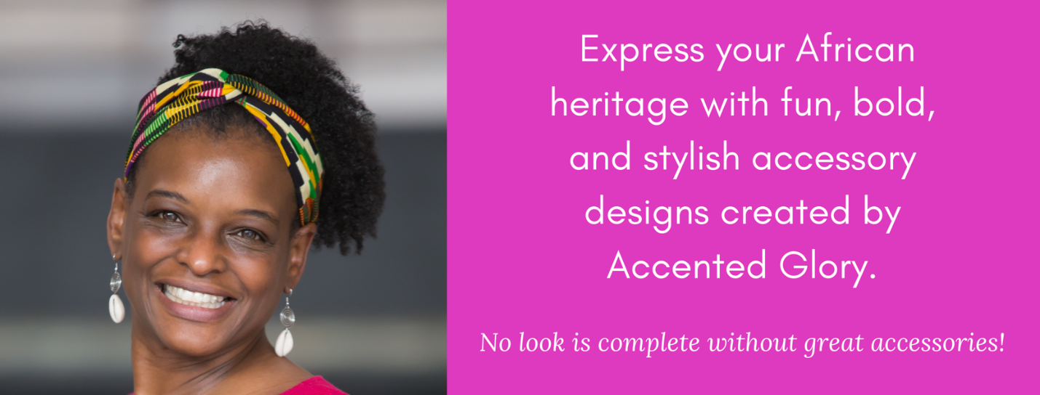
Have you ever considered styling your hair with accessories? Whether you’re on the fence or a hair accessory pro, Accented Glory has a design just for you! Accented Glory is a handcrafted, women's fashion accessory brand, specializing in natural hair accessory and jewelry designs. Accented Glory’s hair accessory designs are created with fabrics and materials that minimize damage to textured hair, making their accessories perfect for naturalistas. Visit [your website] to learn more about their designs, which can be purchased on Etsy and Amazon Handmade.
Your Name and Title

